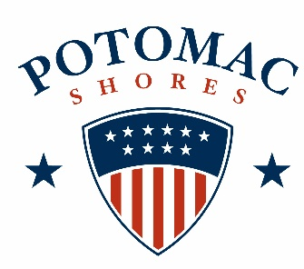
Dog Pool Party
Saturday, September 21, 2019
10:00 AM to Noon

Please read and sign the Waiver and Release of Liability below. No dog will be admitted without current vaccinations.

Waiver and Release of Liability
In signing this release, I acknowledge that I understand its intent, and I for myself, heirs, executors, administrators and representatives, do hereby agree and will absolve and hold harmless Potomac Shores Residential Association, Associa Community Management Corporation, corporate sponsors, cooperating organizations, and any other party of persons connected with this event in any way together with their representative successors and assigns (the “sponsors”) singularly and collectively, for and against any blame and liability for any injury, harm, loss, inconvenience, or any other damage of any kind whatsoever which may result from or be connected in any way to my participation in the 2018 Potomac Shores Dog Pool Party . I fully agree to be legally and financially responsible for any damages caused by my pet to another pet or person. In addition to the absolute and unqualified release from all liability, I hereby represent that I am physically capable of participating in this event, that my pet is licensed and has all current vaccinations, that I will observe all event and facility rules, that I will generally conduct myself, and ensure that my pet (s) conduct themselves, in a safe and prudent manner while participating in the event and hereby absolve and hold harmless the sponsors from any damage I may sustain because of any breach of these representations. I hereby consent to and permit emergency treatment in the event of injury or illness while participating in the event. I also hereby give my permission to Potomac Shores Residential Association, Associa Community Management Corporation, and the sponsors to use my name and any photographs taken of me during the event for promotional materials or publications.
I certify that I have read this wavier and release and understand that it is legally binding by me.
Signature: Date:

- Owners are required to sign a waiver. All dogs must have current vaccinations and county license. Owners will need to provide proof when registering. County tags indicate dog’s compliance.
- One dog per human owner.
- All dogs must be spayed or neutered.
- During the event, the tag must be securely attached and visible on the collar of each participating dog.
- All owners must have doggie doodie bags and clean up after their pet.
- Children under 16 must be accompanied by an adult.
- For every person’s and dog’s safety, all dogs MUST be on a leash when entering and leaving the pool.
- Well-mannered dogs and their (well-mannered) owners are welcome! Either displaying aggressive behavior will be asked to leave.
- No humans can be in the water at any time. Please help your dog into and out of the pool.

Please consider the temperament of your dog before registering. We want this event to be enjoyable for all!
Owner’s Name: ______________________________________________________
Address:
Email:
Phone:
Dog’s Name:
Breed:
Circle One: Male OR Female
Spayed/Neutered: Yes No
Veterinarian’s Name: Phone:

For Office Use: Date of Registration Vaccinations/License:

